*Code Fighters*

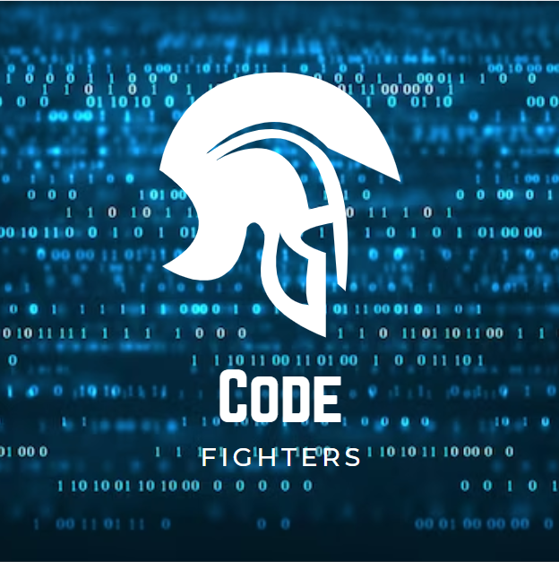

Table of Contents

Project Topic: Game of Math 3

Team Members: 3

Boris Belberov 9A 3

Gabriel Dimitrov 9V 3

Alexander Sivkov 9B 3

Stanislav Petrov 9G 3

Scrum Trainer 3

QA Engineer 3

Backend Developer 3

Backend Developer 3

Technologies used 4

Summary: 6

**Project topic: Game related to Math**

The theme of the project was to create a C++ game related to math and numbers.

Our game idea is a combination of two games - where you have to calculate mathematical expressions to win.

Team Members:

|  |  |  |  |
| --- | --- | --- | --- |
| C:\Users\GABI\AppData\Local\Microsoft\Windows\INetCache\Content.Word\Борис.jpgBoris  Belberov 9A | C:\Users\GABI\AppData\Local\Microsoft\Windows\INetCache\Content.Word\Аз.jpg**Gabriel**  **Dimitrov 9V** | C:\Users\GABI\AppData\Local\Microsoft\Windows\INetCache\Content.Word\Александър.jpgAlexander  Sivkov 9B | C:\Users\GABI\AppData\Local\Microsoft\Windows\INetCache\Content.Word\Станислав.jpg**Stanislav**  **Petrov 9G** |
| **Frontend** | **Scrum Trainer** | **Backend** | **QA Engineer** |

**Technologies used:**

* **C++ (language used to make the game)**
* **Git Hub (version control)**
* **Word (documentation)**
* **Teams (used to get the team together)**
* **PowerPoint (presentation)**
* **Excel (table)**
* **Visual Studio Code (used to make the game)**
* **Visual Studio (used to make the game)**



  

**Summary:**

**1.Our goals**

**- Our goals are to make sure that the code works correctly and its functions have the expected result.**

**2. Main stages of the project**

**- Create a repository**

**- Creating the game**

**- Documentation, presentation and excel table**

**-Release the first version on GitHub**

**3.Summary**

**3.1 Aims**

**3.2 Main stage in the implementation of the projet**

**3.2.1 Creation of the repo**

**3.2.2 Creation of the game**

**3.2.3 We created the documentation and**

**3.3 Implementation of the project**

**3.3.1 Technologis used:**

**1 - C++**

**2 - GitHub**

**3 - Word**

**4 - Teams**

**5 - Power Point**

**6 - Visual Studio Code**

**7 - Visual Studio**

**4. Conclusion**

**We created this game to increase literacy around the world**